Name _____________________________________________________________________________
-at word family
Directions: Choose a cat. Color it appropriately. Write the word for the picture that is on the cat. All words will end with -at.

- 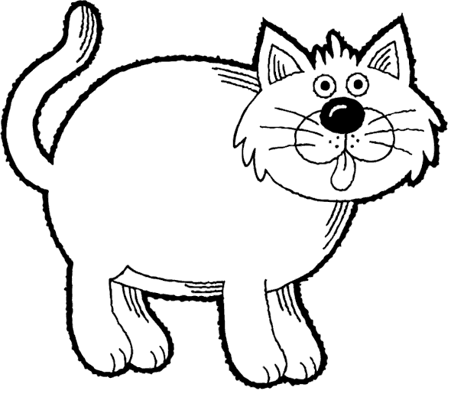 __________________________ 4. ___________________________

- __________________________ 5. ___________________________

- __________________________ 6. ___________________________

Choose 1 –at word and write a sentence.
__________________________________________________________________________________
__________________________________________________________________________________

